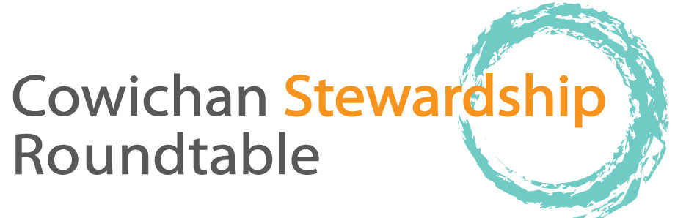

thursday, JUly 16, 2015 Meeting Minutes,
10-2:30 pm., Stoltz Pool Provincial Park, picnic site, day-use area,

10:00 Welcome by Deb Toporowski, Cowichan Tribes

Introductions

Parker Jefferson, River Update

The River is currently running at 5.5 cubic meters per second (CMS) but moving to 4.5 is being discussed. DFO is reluctant to go that low as it could mean that we will be at 0 storage this fall and would no longer have any control over flow. If flow drops below 4CMS there could be challenges for the mill. Parker is feeling optimistic about increasing the storage at the lake, decision about water licenses could happen within the next few months which would be a step in the right direction. DFO is concerned about the spring Chinook run. There are 50 Chinook currently in the river, a remnant from the biggest pre European contact run. There is now a complete ban for angling on the river because fish are stressed with high temperature and low oxygen water.
Tim Kulchyski, traditional fishing and First Nations perspectives
Quote from Tim: “This is the first year we have an official count from DFO of early run Chinook. The current run is small a piece of what it used to be. This was once the main run supporting local people”. Tim describes traditional fishing methods passed down through the generations. The fishing methods he describes are important not only for catching fish but for keeping the cultural experience alive.
Don Closson, History of Cowichan River Provincial Park
During the 1980s and 1990s the provincial government was increasing the amount of parkland in BC. Local people spoke out about the desire for a corridor park. Trades, purchases and donations ensued until the different chunks of park were connected around 1995.
Joe Saysell, History of Cowichan River Provincial Park
Joe grew up on a productive section of the river known as Willow Run. His dad was one of the early fly fishermen. Joe was in tune to the fact that in order to have fish you needed water and habitat. The idea of having a river corridor park goes back to the mid-70s. Slow political timescales and changes in government stalled the process until the 90s. Joe took out some ministers for a drift and they loved the idea of creating a river park. There were two options, a couple of parks around Skutz and Stoltz or a corridor. The public voted 98% in favour of the corridor. He got the minister to give $1.25 million to the project by getting matching donations of property.
Lunch,
Parker Jefferson and Bob Crandall, fry salvage area, demo and discussion
Visited shady side-channel pool that is being monitored for fry. Pool was 3 degrees cooler than river. The fry salvage program has saved 34,000 fry this year from pools that were becoming too warm and de-oxygenated or drying up. Demonstration of how fry are caught with pole seines and moved to better habitat was given.
Ray Demarchi, Amendment to the JUB Sewage Outfall Project
There has been a formal agreement made with Cowichan Tribes regarding the sewage lagoons. Part of the agreement is to move the sewage outfall to satellite channel. Helen Reid of Cowichan Tribes says that it has been a long process of discussion about this move and Council and Chief has agreed to the pipeline move, granted all environmental assessments and studies are completed, which is very exciting.
Don Closson, Visit to Stoltz bluffs restoration
There had been long-term concerns from residents about a huge sediment load being deposited into the river annually. This was the biggest water quality concern at the time as sediment could be impacting fish egg survival downstream. The project cost $1.5 million and is now world-renowned. Don provides description of the highly engineered project which stopped sediment from entering river from this point source. Joe Saysell says that there are differing opinions on the project. It likely helped chum but made it worse for steelhead as it made them easier to catch (because of clear water). Also the silt likely had natural functions like feeding the eelgrass beds in Cowichan Bay.
Genevieve thanked everyone for coming and closed the meeting.
Future meetings: salvaging of fry power point presentation by Bob Crandall and Parker Jefferson, Tim Clermont on Wildlife Management Area (WMA) for Somenos Marsh in autumn
Our meetings are always the third Thursday of the month; we will be having a meeting in on August 20

